MaRs CLUB HARD TASK 3
Behaviour tree for Battery checking:
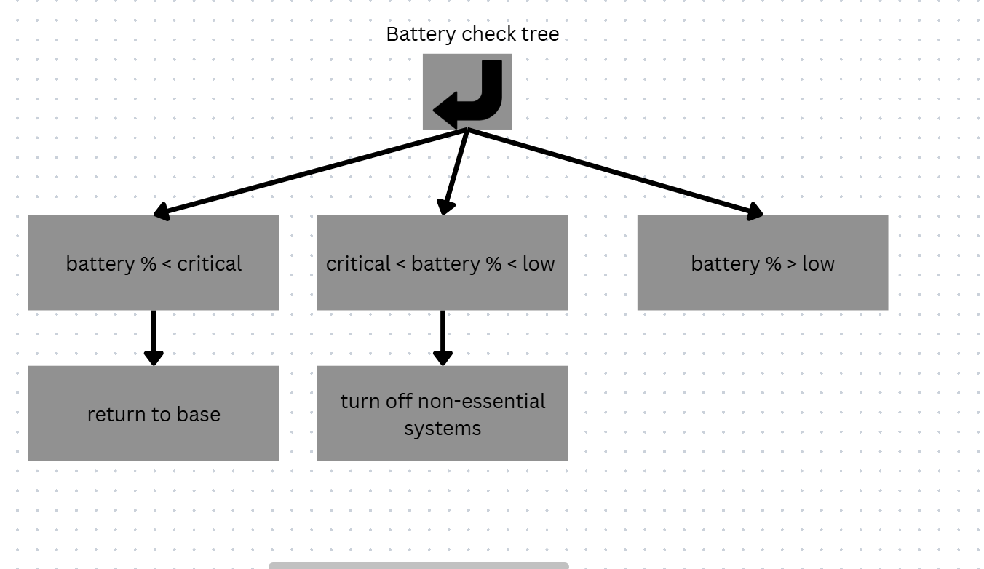
Behaviour tree for Navigation.
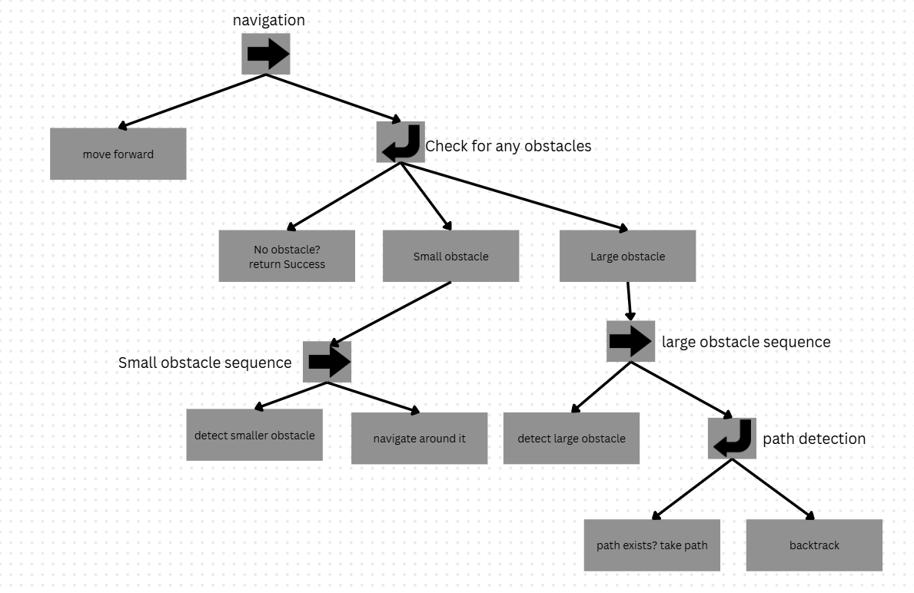
Questions:
- A Fallback node helps in making better decisions since it allows the rover/system to try out each and every node/strategy until one succeeds or ensures safety in case of a failure.
- Long If Else is pretty messy to handle and not easy to list out document to visualize every node/action and dependencies and what action being taken in case of a situation. In simple words, it makes visualization, planning and understanding the decision and behaviour logic of a system much easier.
- We include another “safe” variable called “low” that accounts for the case when robot’s battery level becomes low to turn off some un necessary systems but can still explore around. (low>critical level).

